Roll Number: 16010122158
Experiment 10 : Graph Numericals
Perform DFS using stack and BFS using Queues for the following graphs.
The graphs will be allocated by your Lab Incharges
Tabular Format should be followed while solving

Q. 1
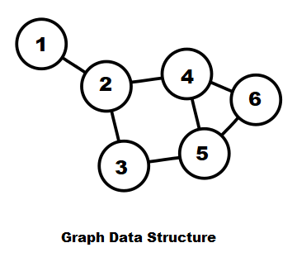
Starting vertex: 3
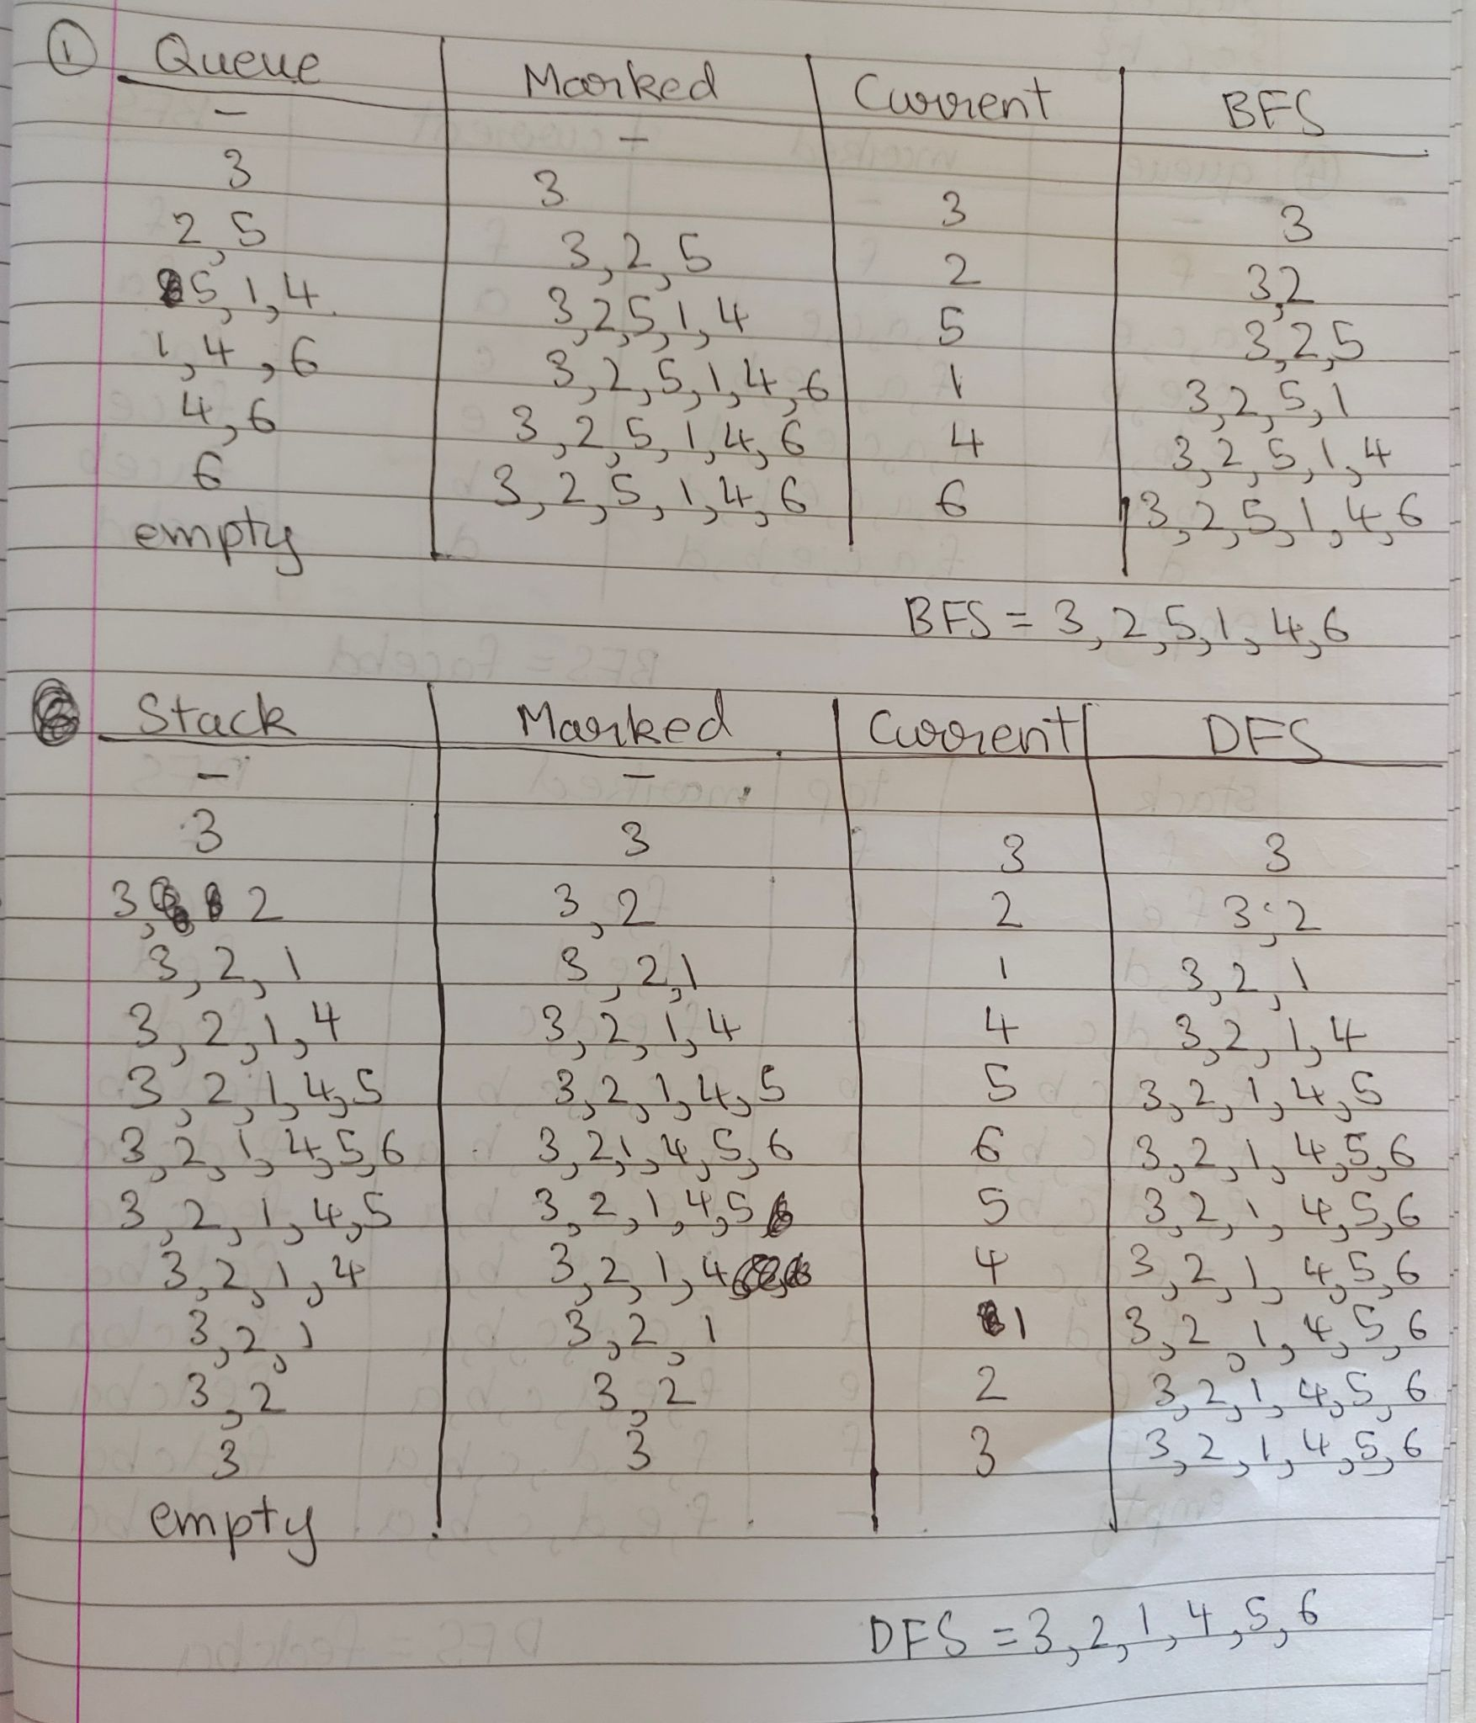
BFS = 3, 2, 5, 1, 4, 6
DFS = 3, 2, 1, 4, 5, 6
Q. 4
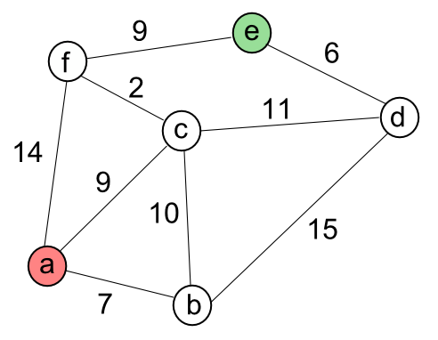
Starting vertex: f

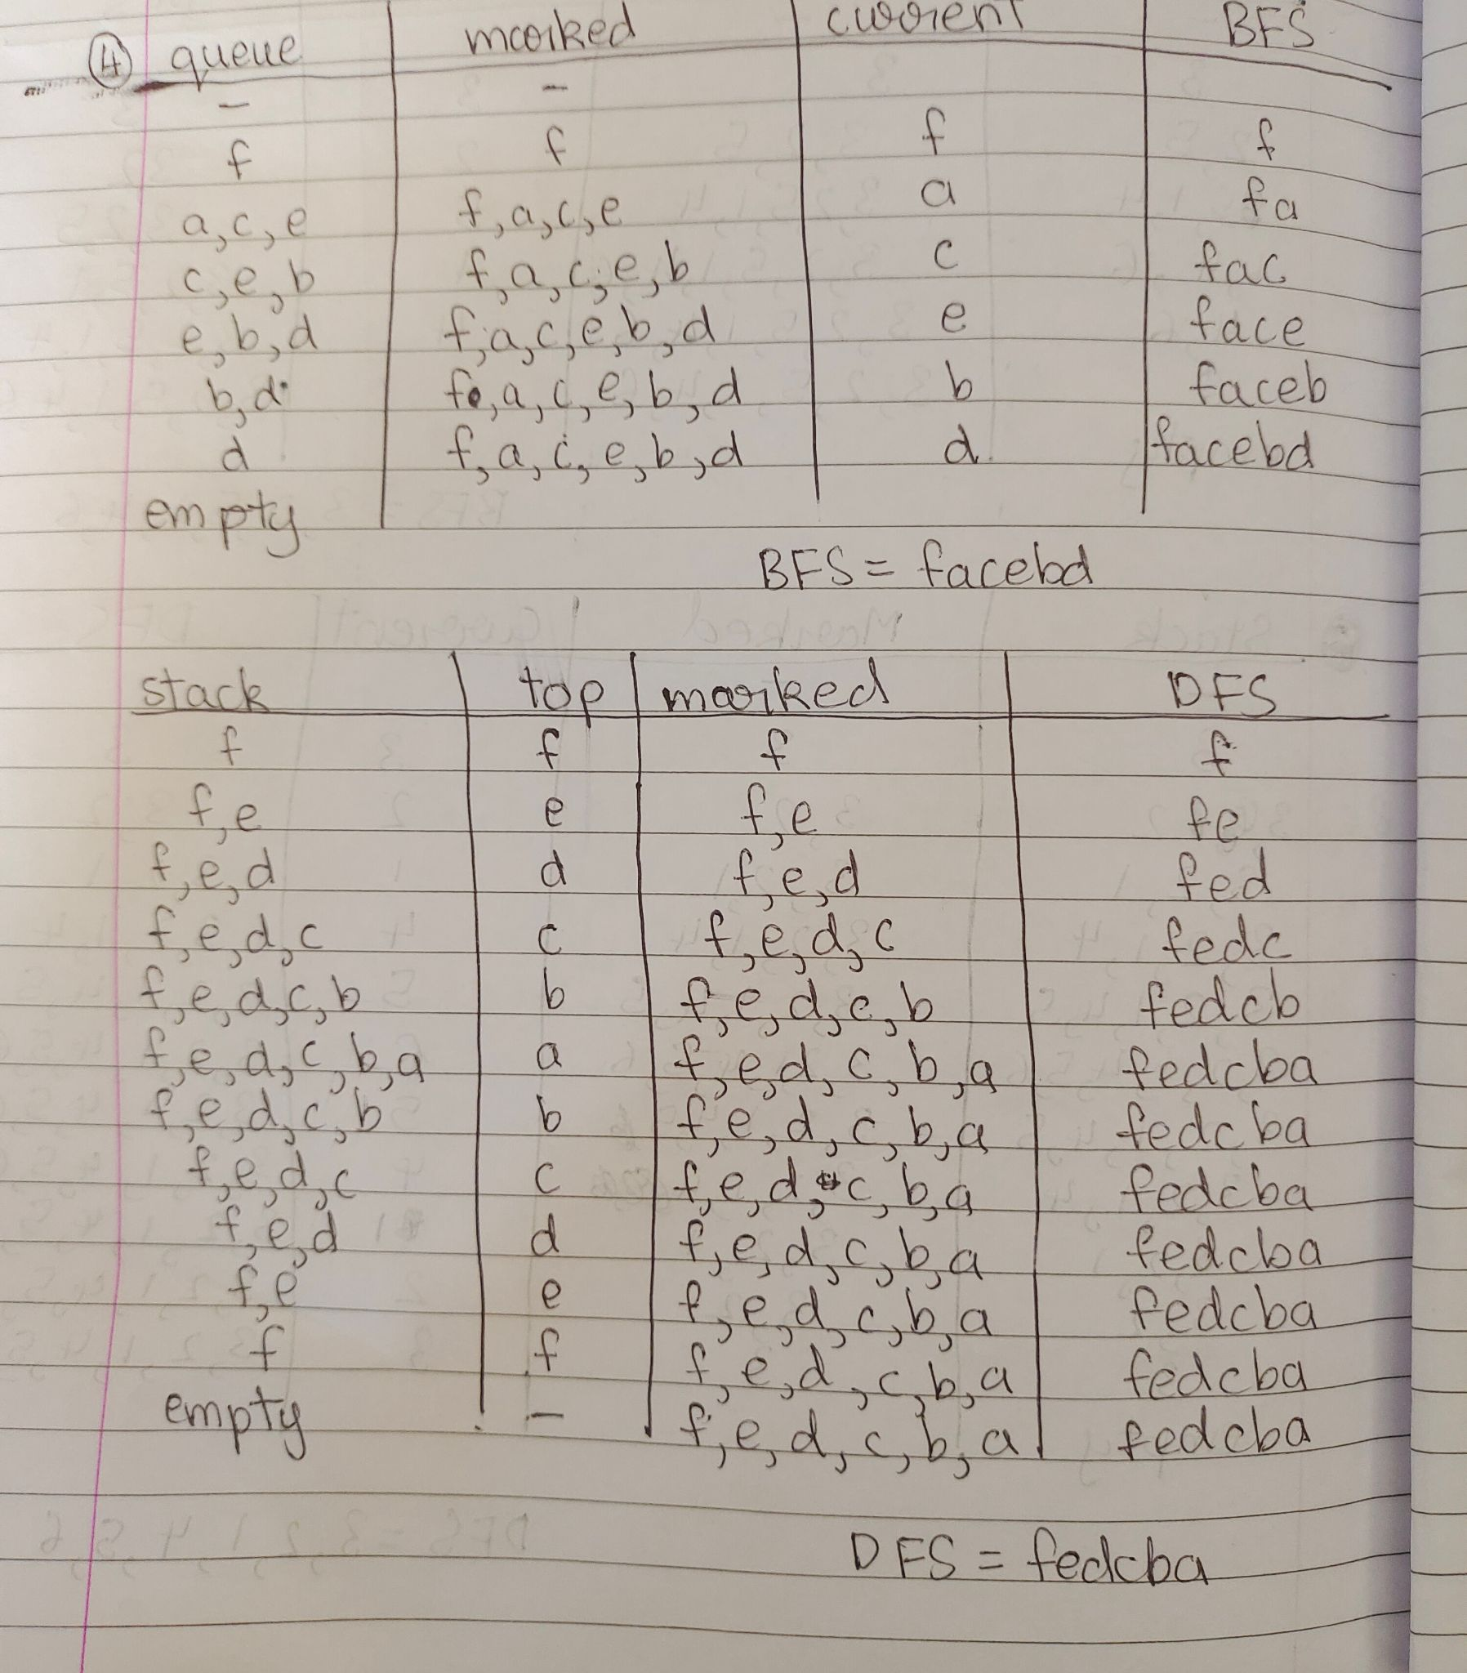
BFS = f, a, c, e, b, d
DFS = f, e, d, c, b, a

Q. 5
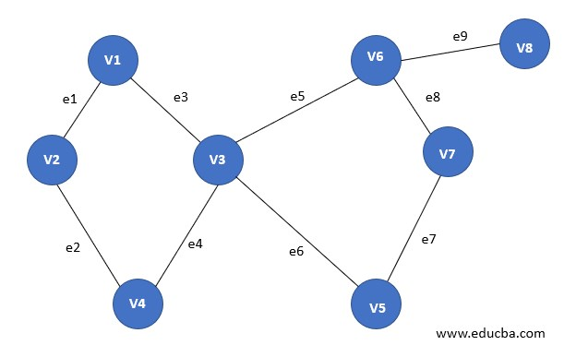
Starting vertex:v5
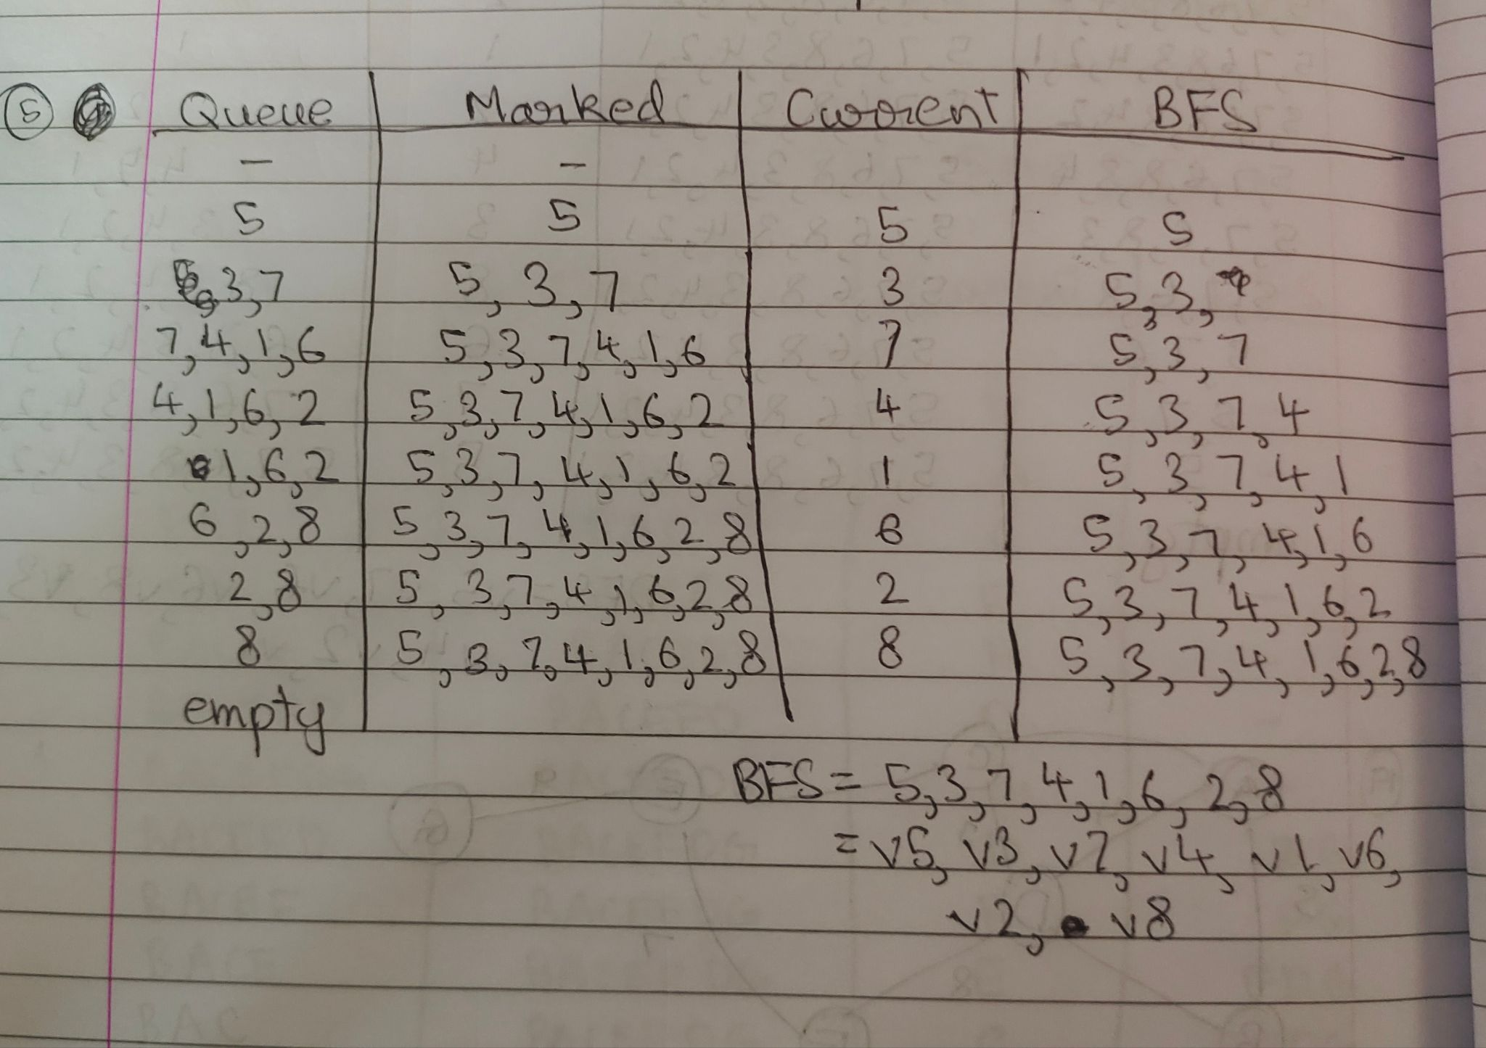
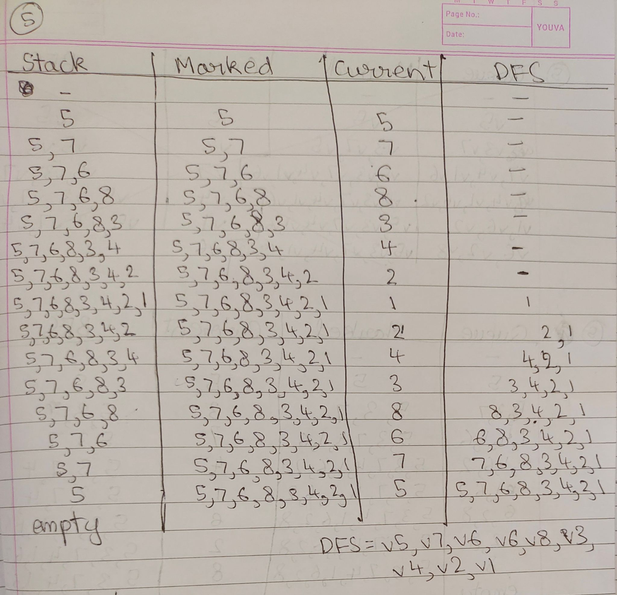
BFS = v5, v3, v7, v4, v1, v6, v2, v8
DFS = v5, v7, v6, v8, v3, v4, v2, v1

Q. 19
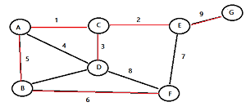
Starting vertex: B
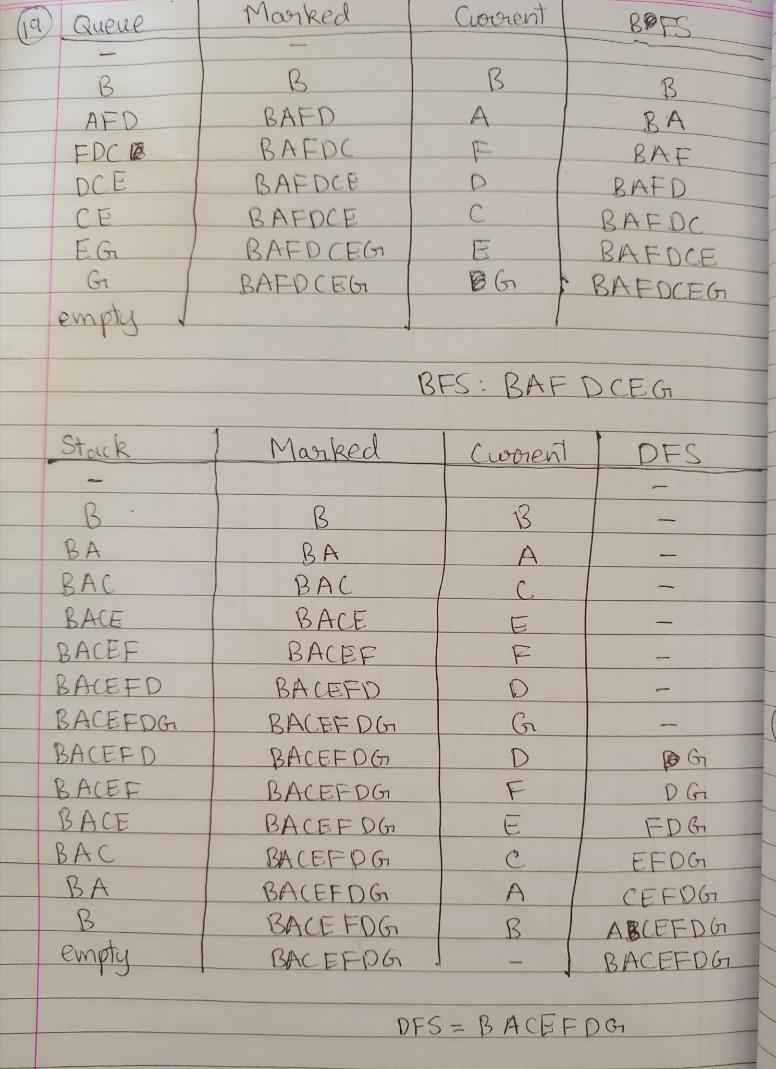
BFS = B, A, F, D, C, E, G
DFS = B, A, C, E, F, D, G

